If you are dealing with suicidal thoughts, if you believe the world might be better off without you, it is definitely time to seek help.  There’s no shame in reaching out for help in a situation that is so overwhelming. Those who love and care about you will be forever grateful that you took the brave step of searching for help before you did something that would take you away from them forever.  Asking for help can be difficult and even more challenging when you need help for the terrible thoughts you are having.  When you ask for help, you are asking for one of the most important things they could possibly do for you and friend and family.  When you are trying to figure out how to ask for help, there are some things you should remember:  - You are not a bad person  - There really is another solution  - Give yourself more time  - Do not be alone |  |  | Warning Signs of Suicide  Talk  If a person talks about:  - Killing themselves.  - Having no reason to live.  - Being a burden to others.  - Feeling trapped.  - Unbearable pain.  Behavior  - Increased use of alcohol or drugs.  - Acting recklessly.  - Withdrawing from activities.  - Isolating from family and friends.  - Sleeping too much or too little.  - Visiting or calling people to say goodbye.  - Giving away prized possessions.  - Aggression.  Mood  People who are considering suicide often display one or more of the following moods.  - Depression.  - Loss of interest.  - Irritability.  - Humiliation.  - Anxiety.  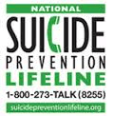  Resources  Creighton Counseling Center  Phone: 402-280-2735  Harper 1034 |  |  | What to know about Suicide  - Depression and suicidal thoughts are two of the most frightening things a person can face in their lifetime. Unfortunately, acting on those suicidal thoughts is a far too common scenario for many across the world, including students. In fact, suicide is the second-leading cause of death for those between the ages of 15 and 24.  This guide is dedicated to helping those who are suffering with suicidal thoughts.  It is also designed for concerned friends and family members who worry that someone they love will experience death by suicide.  It is also meant for students, so that they might spot the warning signs of suicide in others – or in themselves – and find the proper resources.

Mental Health, Depression, & Suicide  Depression has long been linked to suicidal thoughts and suicide attempts. Learning how to recognize depression, spotting when it gets worse, and finding the right resources can literally mean the difference between life and death.  Recognize depression.  Depression is quite common. Signs of depression include a feeling of helplessness, no longer finding joy in activities you used to enjoy, sleep changes, loss of energy, anger or irritability, reckless behavior, self-loathing, and more.  What if it’s not depression?  Sometimes, what seems to be depression is actually pointing to something else. Evaluation by a mental health professional is the key to figuring out what is wrong.  When depression gets to be too much.  Everyone gets depressed at some point in their lives. If depression seems to only get deeper and you feel as though things will never get better, immediate treatment is necessary.  Resources to fight depression.  Get in touch with a counselor. There is no shame in getting help, and it can relieve the pain.  Talk to friends. Be honest. You might be surprised how willing they are to help.  Take medication as directed. |  |  | MYTH: Nothing will stop someone who is serious about suicide  TRUTH: There is often a belief that someone who truly wants to die by suicide will do so, no matter what kind of intervention friends and family take on their behalf. It’s important to remember that those who die by suicide may be conflicted about the act, and if they saw any other way out, they would take it. Their desire to live is not gone; their desire to live without pain has simply become the stronger force. |  |  | 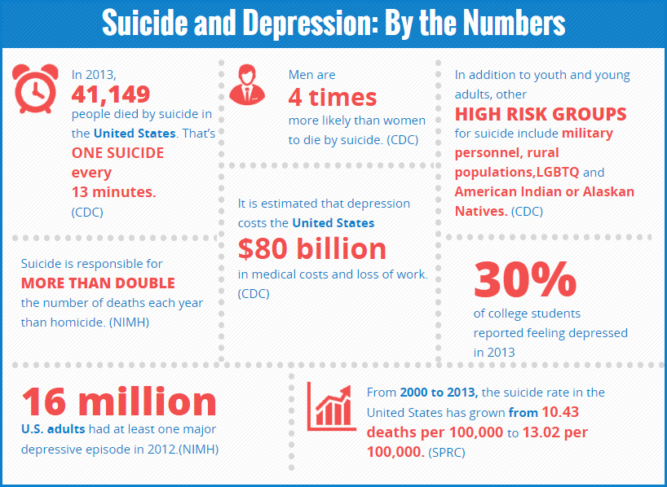  MYTH: Talking about suicide might prompt someone to do it  TRUTH: This is a dangerous misconception, as it seeks to sweep suicide under the rug. But by staying silent about suicide, there is the risk of making the suicidal person feel even more alone and isolated, which doesn’t bode well for their state of mind. Discussing suicide can make someone open up about their own suicidal thoughts, and that can lead to then getting the help they need.

